**Table of Contents**

1. Introduction and Objective…………………………………….1
2. System Analysis……………………………………………….2
3. Data Flow Diagram……………………………………………4
4. S/W & H/W Requirement Specification………………………6
5. System Design…………………………………………………7
6. Screen Shots with coding [Including Database table]…………
7. Validation Checks………………………………………………
8. Implementation and Maintenance………………………………
9. Testing (Testing techniques and Testing strategies) ……………
10. System Security measures………………………………………
11. Future scope of the project……………………………………...
12. References………………………………………………………
13. **Introduction**

**Purpose**

The main objective of this project is building a website which will help farmers to make the effective cultivation by providing those up-to-date tools and make path to produce more products with less time and resource by hiring agriculture tools instead of buying any equipment they require through online. Here if suppose some village farmers want to use this facility and want to learn how is it possible and how they can use e-resource sharing to rent tools, they should be given training based on it and If they have knowledge of computer then they can directly register in the site and get access to each tool the need, otherwise the customer can directly contact with the vendor who will schedule for them the tool they want and explain in details more about the renting issues.

**Scope**

By investigating most websites available for Agriculture tools we realized that most of the customers are unable to buy the tools, therefore in order to ease and get the required tool for their farms, vendors introduce this platform of hiring tools to the customers through manual basis. Hence to make easier we create such a platform for both the vendor and the customer to get easy access to each other.

**2. System Analysis**

This is a brief specification of what the required system must do. This basically includes system requirement analysis and the study of the system itself.

After deep discussions in between us we realized that there is need to create such a platform in order those vendors who wish to rent the Agriculture instruments in an online format to benefit and help them reach to those in need of the resource through online.

**Identification of Needs**

Agriculture E-resource sharing help the vendors to easily rent their resource and also helps the customers to hire easily and get access to these resource while they are at their various destinations with less time and energy.

This will help the vendor also an error free, reliable, secure and faster way of renting his/her resources.

This site will also help customers to search easily whatever item they need with less time and also will ease for the vendor to record the data of his/her customers easily in computerized way to reach relevant information of thousands of customers quickly.

**Preliminary investigation**

After we have studied and discussed deeply in many agriculture resource websites we got some effective guides towards visualizing the features that were needed to be put together in the system and the desired output of the vendor as well the customers to ensure the system to become functional.

These specifications that we have got from the observations and deep studies we made from the Agriculture resource sites guided us how the system should look like; it helped us in understanding some of the basic structures of the web application which we were supposed to develop.

**Objective**

   The objective of the project is to develop a website for Agriculture E-resource sharing which will maintain the total system in computerized way and generate required report that are very essential in every single manner.

**Scope**

Our project is to develop a computerized system which will automate the process for renting Agriculture resources.

**The scope of the proposed solution contains:**

Providing security to the data entered by both customers and vendor.

Minimizing the bulk documentation.

Easy maintenance of Data.

Reducing manpower and overhead work.

**3. Data Flow Diagram**

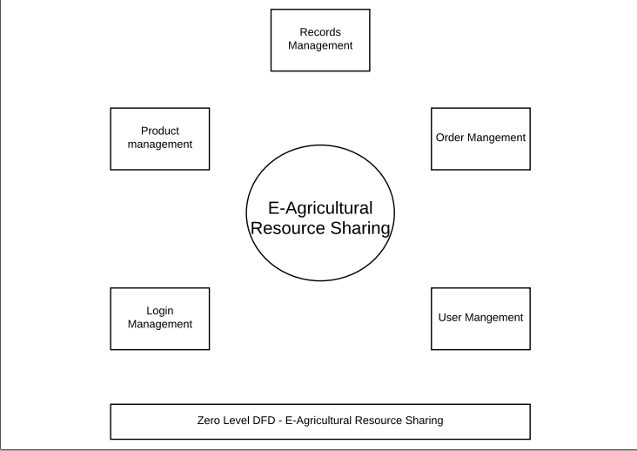

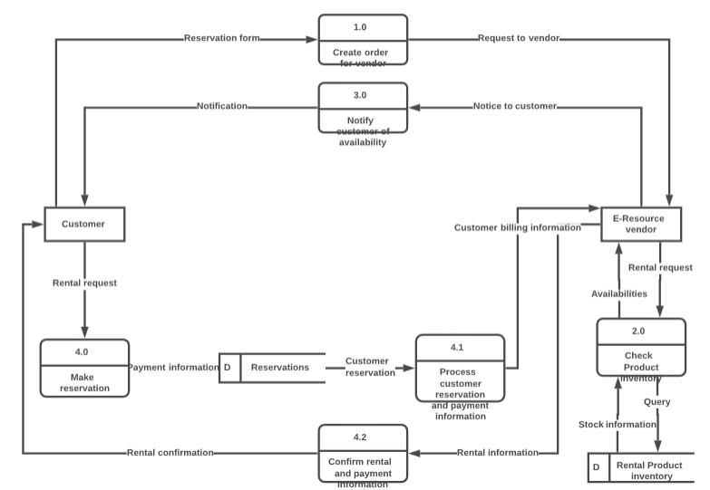**Data Flow Diagram Logical**

**4. S/W & H/W Requirement Specification**

Every application has specific goals and provide services for some particular purposes. For each goals and purpose, the application performs a process or several processes that the application provides to the users. The following are the Software and Hardware requirements for this E-sharing resources website.

**Software Requirements:**

Operating System : Windows

Technology : Bootstrap & ASP.Net

Web Technologies : Html5, JavaScript, CSS

IDE : VB.Net 2015

Database : SQL

Browsers : internet explorer & Chrome &

Firefox…

**Hardware Requirement:**

Hardware : Laptop, Desktop, Mobile devices (Android, IOS)

Speed : 1.1 GHz

RAM : 512MB

Storage : 500MB

Input devices : Keyboard, Mouse, and Touch Screen.

Output device : Display Screen

**5. System Design**

**System Design: (admin)**

ADMIN

USER DETAILS

UNAUTHORIZED

USER

VIEW

ORDERS

UPLOADED PRODUCTS

CHECK

Yes

No

Process

**User:**

USER

PRODUCT SERACH

UNAUTHORIZED

USER

PRODUCT UPLOAD

VIEW PRODUCT

CHECK

Yes

No

AUTHORIZED

USER

COMMENTS

RATTING

END PROCESS

**User Case Diagram:**

USER DETAILS

VERIFY LOGIN

LOGIN

BOOK NOW

PRODUCT SERACH

UPLOAD PRODUCT

COMMENTS

RATTING

VIEW COMMENTS

VIEW PRODUCT LIST

ADMIN

USER

**Class Diagram:**

LOGIN

USER NAME

PASSWARD

CHECK VALID

INVALID

User Login

Search Product

View Product

Post Comments

User Process ()

Admin Login

Upload Product

View User Detail

View Rank

Admin Process ()

**Activity Diagram:**

Start

View Product

Search Product

Post Comments

Update Own Details

User Details

View Rank

Upload New Product

**6. Screen Shots with coding**

**7. Validation Checks**

The term validation means checking. Whenever any person is going to develop any kinds of technology. There are many tools and organization, which are working to validate the work, which any one did. The purpose of validation means to check the source code of any project and determines the formatting and standard, which must be followed during the development of the project. When the project is not following the standards and formatting according to the standards of the organization. The validation of the project would have failed and it will not validate.

Validation can help to get better in search engines. When there are, any errors found in the code of the project it would affect the performance and make a big impact on the project. If the code is found invalid, it means that the project does not follow the rules and the project may not be validating.

**Validation Practices:**

When the project having the standard and compliant code is the best practice for the validation. It encourages the best practices. While most of the organization are going to create the error-free, code and make few validation errors, and most of the developer make more errors. The validation practices can help most of the developer that learn from their mistakes.

**Multiple Device Validation:**

According to our project, it is the most important validation. If we compare recent time with the last 15 years, there are big changes come in the technology field. In our project, we remove the device validation check. Because most of the users are going to use different devices like smartphones, tablets and much newer technology and they are accessing the internet through these different devices. Our project is related to the internet based, so any users can access it from any device and anywhere but he must have access to the internet. This is the positive point about our project that we remove the multiple device validation.

**User Account validation:**

Our project has user account validation. Whenever any clients are going to access our website. They can access the main page but if they are ordering some product, they must create their user account and after creating the account then they can log in to their account and using the other features of our project. However, it is compulsory that they can create a valid account. If their account is not valid, they will not be able to log in.

**8. Implementation and Maintenance**

**Implementation:**

Implementation is the stage where the theoretical design is change to the practical system. First, we are going to gather the requirements. Before starting the implementation all, the requirements about your project must know. After the requirements gathering, we are going for the designing stage of our project where we are going to make the theoretical design of our project. We specify all the modules of our project and their relationship between the modules. Once the designing stage is complete then we start the implementation stage. In implementation, we are going to start the coding part of our project. In implementation, we convert the theoretical design of our project to the practical system. It is the most critical stage in which a new system is going to implement for achieving the goal successfully and it will be confirming that the system will work effectively. In this stage, we give the new system to the user or client for practical use.

**Maintenance:**

After implementation stage, the next phase is the maintenance stage. In maintenance, we are going to take care of the system. When the system is given to the client for the practical use, after some times the user find some bugs or the system is not capable to provide the desirable output for the client. The system is going to the maintenance stage. The developer tests the system again if it is possible that the bugs are solve in maintenance. If the bugs are not solving in maintenance, then the developer again go back to the designing stage. They are working on the designing stage once they fix the error in that stage. After fixing it there then again, the implementation stage is going to start and they bring changes in the system. After completing the implementation, the system in given to the client for the practical use. After some time, the system will need some updates or upgrade so in maintenance stage all these issues are going to be solve in the future.

**9. System Testing**

The main objective of testing is to find the bugs within the system. Testing is a lengthy and costly phase of system development. The system must be tested whether the user requirements have been full filled or not? whether the expected outputs of the system are the same as the actual outputs or not?

It takes different aspect in consideration like checking, the functionality of different modules in the system the, dependency of each module, the overall interoperability of subunits. Initially, we start testing process from unit testing, then we integrate the units and performing integration testing later on functional testing at the end testing process is going to end with overall system testing.

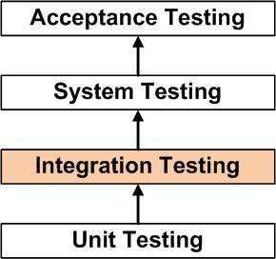

Definition by ISTQB (International Software Testing Qualifications Board)

There are different methodologies of testing a work product and types of the testing process on work product.

**Unit testing**

In unit testing, the testing is done by the developer itself rather than tester because an individual component or module of the system/software will be tested. It will perform basic tests on the small parts of the system whether its functions are accurate or not. That is why it is done by the developer he produces the system unit by unit.

**Integration testing**

After each integration of unit, the system should be tested to verify the system is working as one piece or not. The objective of this test is to find out the fault in communication or interaction among different modules of the system.

**Functional testing**

In the functional testing phase, the functional requirements of the are going to check. In this part testing, we work on test design. We are going to design test cases and test suits. Like:

Functional testing is determined on the basis of the below items:

Valid Input : classes for the valid must be defined and accepted.

Invalid Input : classes for the invalid must be defined and rejected.

Functions : functions must be well defined and exercised.

Output : classes of application outputs identified must be exercised.

Systems/Procedures : interfacing procedures or systems must be called.

**System Test**

In this phase of testing the tester ensures the entire system comprises of different parts or modules meet the requirements. It tests the complete functionality of the system to ensure known and predictable outputs.

**Acceptance Testing**

It is the last stage of testing which is done by the clients or the user of the system. It verifies whether the business requirements are fulfilled or not. The clients will accept the system or software only when all the functions and features are working as it was expected.

**Project Testing**

1. After we have completed the designing and coding phase we start through the project testing. In which we followed all the above testing procedures.
2. We start from the main page of the website whether links are working or not. Whether all the pages of the website are accessible? We did the same for all the available pages on the website.
3. Then we checked all the ASP.NET text box and Buttons are submitting the data to the database or not.
4. We have done the checking on login page what if the username or password is wrong. Whether it will redirect to the desired page on clicking log in button or not.
5. We have done the Compatibility testing or responsiveness of the website how it will look like in different screen view.
6. We have tested the overall functionality of the website whether it will work as we have expected in the design phase or not.
7. We have tested the website we the visual studio debugging tool and different browsers like Google Chrome, Mozilla Firefox, Microsoft Edge and so on.

**10. System security measures**

Security is one of the most difficult issues when we talk about E-resource sharing website. Cases like identity theft and payment duplicity are mostly increasing day by day in electronic payment segment. It is of utmost importance for a vendor to give his/her customers safe and secure environment.

$

d

Order Contact

Response Response

Customer Merchant Website payment Gateway

settle confirm

M

Transfer

response

Bank E-merchant payment

processor

In order to make sure there are proper security measure the vendor or owner should the following auditing to protect from all threats.

## Monitored suspicious purchasing activity

## As an owner of the resource you should be aware of the various types of suspicious activities that could be the main reason for duplicity.

## Address verification system for all transaction

## It is indeed important for the resource owners to predict and analyze that the person making the purchase is truly a cardholder. Various techniques can be utilized to prevent this fraud. Implementing the address verification system in the e-resource sharing site is the best way to analyze and verify the fraud. The system will check if the billing address is correct by verifying it with cardholder’s data from the issuing bank. As a result, person with a stolen card or card number doesn’t have the access to the wrong billing address.

Incorrect billing address may not necessarily mean that the transaction is fraudulent hence it is advisable to take additional security measures to identify the customer.

## Safe login screen

Developing of E-resource sharing website mostly starts from the Login Page. It will be easy for the hackers to get access into sensitive data of the customers if you don’t secure the login access to your website.

Implementing this safety protocol is somehow easy, but it can successfully protect many security issues.

But in our project we never had an online payment option therefore we used cash on delivery method which is more secure and easier for the clients who can’t get access to online payment or do not have credit card or any other online payment option.

This is more secure since its cash on hand immediately after the vendor delivers the ordered tool by the customer.

**11. Future scope of the project**

E-Agricultural Resource Sharing has vast scope right now it is vendor based in future it can be used client based those clients who have extra resources they can share them easily. For example, there is one farmer who has used his tractor for his own land but after completing his work it is completely free available for others to use. Due to the lake of opportunity or market the farmer cannot share his resources properly.

In the future, we can add one module to the website in which a registered farmer can share their resources with others for a fixed amount of time and money. The vendor of the website will put some percentage of charges on that.

**12. References**

**Text Book:**

1. Beginning HTML, XHTML, CSS, and JavaScript by Jon Duckett
2. The CSS Anthology: 101 Essential Tips, Tricks & Hacks by Rachel Andrew
3. Beginning ASP.NET 3.5: In C# and VB
4. DATABASE SYSTEM CONCEPTS by HENRY F. KORTH, S. SUDARSHAN, ABRAHAM SILBERSCHATZ, MCGRAW HILL EDUCATION

**Website:**

<https://www.w3schools.com>

<http://www.w3schools.com/css/default.asp>

<https://getbootstrap.com>

<http://www.webdevelopmenthelp.net>

<https://www.scribd.com/document/325317356/Lpu-Final-Year-CSE-Project-Example>

<https://www.olx.in>

<https://www.royalbrothers.com/bangalore/bike-rentals/tariff>